**Assignment.**

1. **Setting up the HTML Structure:**
   * Create an HTML file with a container div and several child div elements inside it. These child divs will represent items or elements you want to display on the webpage.
2. **Applying Flexbox:**
   * Apply the **display: flex** property to the container div to activate the flex container.
   * Use the appropriate flex properties to arrange the child divs in a row by default.
3. **Implementing Flex-wrap:**
   * Apply the **flex-wrap** property to the container div.
   * Observe how this property affects the layout when the screen size is reduced.
   * While Reducing Screen Size the Cards Will Be Wrapped if there are three cards are showing while reducing the screen size the last card will be wrapped. Meanwhile the layout will not be affected.
4. **Additional Styling (Optional):**
   * Feel free to experiment with additional styling, such as setting a specific width or height for the child divs, adding margins, or adjusting flex properties to enhance the overall design.
5. **Review and Reflect:**
   * After completing the assignment, review the responsiveness of your design by resizing the browser window. Reflect on how the flex properties contribute to a more flexible and adaptive layout.

**Demo Desktop Example:**

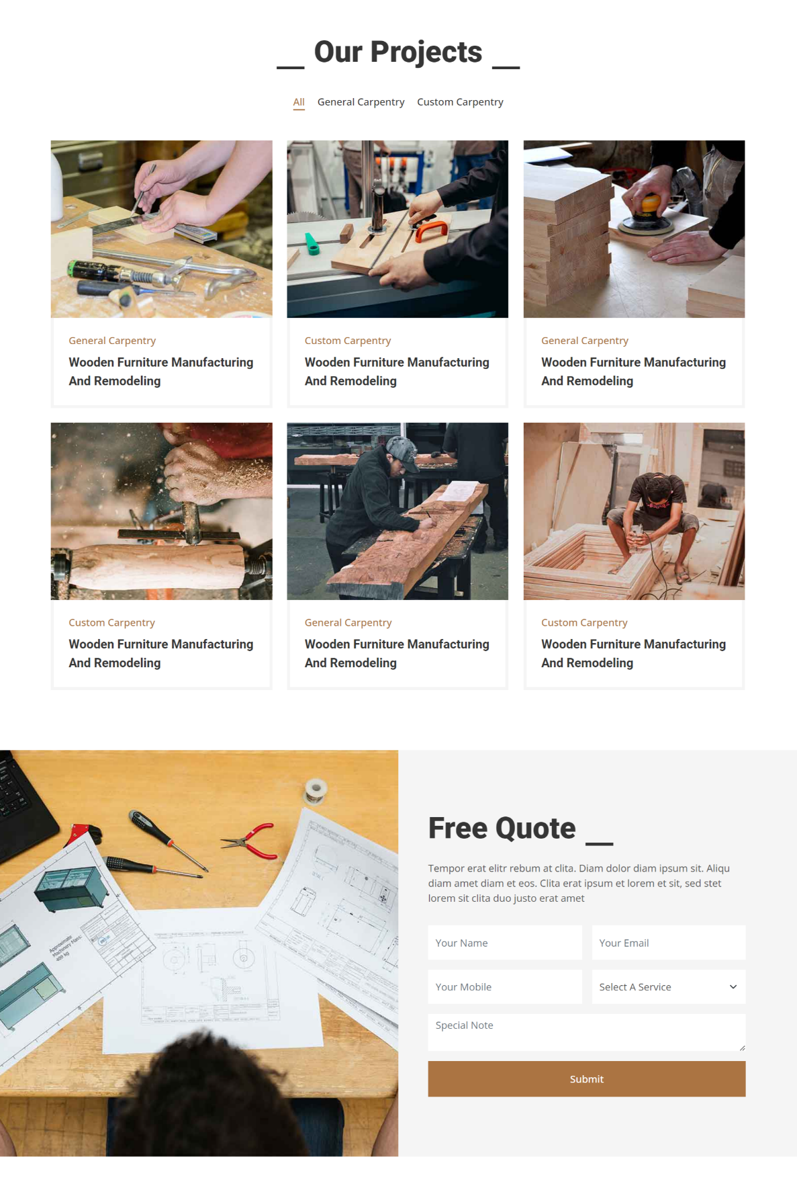

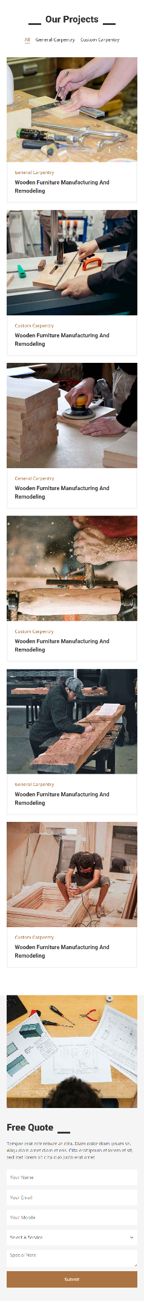

After Flex-Wrap: